**REF: First and second meetings report for the Project for sustainable Water, Sanitation, Hygiene, and Agriculture Programm in Pageri Payam Magwi County, Eastern Equatoria State, South Sudan**

**Project No: *2015.1542.8***

**Introduction:**

Bengo/IAS German signed an agreement with Community Action Water Programm and

Edooss on the 19th June 2015 for the project for Sustainable Water, sanitation, hygiene,

and agriculture in Pageri Payam Magwi County, Eastern Equatoria State, South Sudan

**Project purpose**

The goal of the project is to improve the livelihood of the people of Pageri payam by provision of safe drinking water, promotion of hygiene and sanitation; and knowledge on improved agriculture. Its specific objectives are: (i) improve access to safe water. (ii) Improve community wide hygiene and sanitation practices (iii) Increased and sustained food production in the primary school and community at large.

**Implementation strategic:**

**Meeting with Pageria Payam authorities.**

On 7/7/2015 a meeting was held with the Education department team in the office of Education director in Pageria Payam.

During the meeting CAWP and EDOOSS representatives explained to the team the objective of the project, targetted people and the area which was assessed since 2013.

Education department team appreciated the approval of the project by the donor and urge the team to speed up the implementation because the needs on the ground is great.

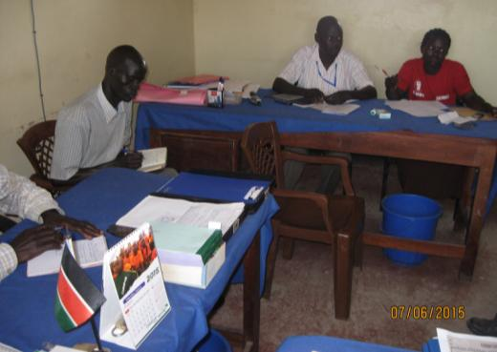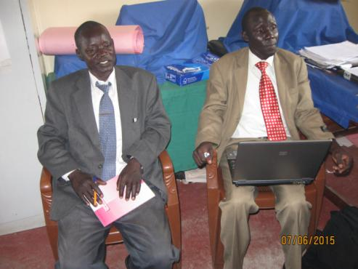

The Director of Education came up with the idea that as the need is so alarming there are schools which are in a very bad position. He requested the representative to accept the changes which they have decided.

* **Kerepi primary school remain on the top list**
* **Kerepi Child hope primary school high priority**
* **Orobe instead of Eyiecsku primary high priority**
* **Royal kids international primary school high priority**

The authority requested us to start with these one first they are all within the same area of Pageria Payam.

**Meetings with schools leadership:**

On the 23/07/2015, the team from Juba went back to visit the schools in their respective location. The team was joint by the school supervisors of the respectives areas.

First school visited was Kerepi Primary school, where meeting was held in the office of the school director Mr. Okumo Angelo, Mr. Stephen Idra Kerepi payam school supervior and the two representative of CAWP and EDOOSS.

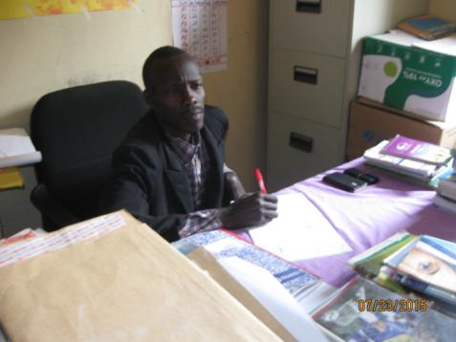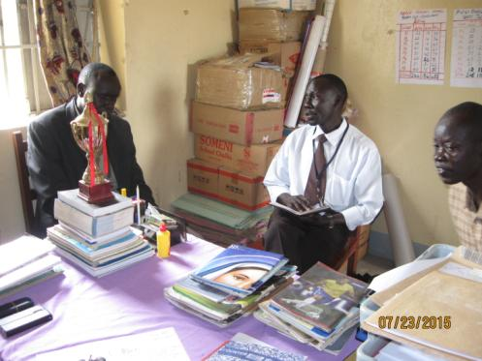

Issued discussed were:-

* The land availability and its dimension
* Borehole location that can be access by the community as well.
* PTA executives training and the pupils
* Type of crops that can do better at this time of season.

Mr. Okumo also updated the team on the enrollment of the school for the year 2015. Girl numbers have risen compare to the previous years. Kerepi primary school have vast land for school development, teacher quarter is just within the school premise.

School football play ground for out doors activities.

**Second school was Kerepi Child hope primary school**. This school has a very good representation of gender balance within the teaching staff. The dupty head of the school is a female and three other teachering staff. The school is constructed out of mud soil. They have only one tukul room which is use as headmaster office and shared by the rest of the staff. The school lacks so many things, ranging from classroom building, staff office, kitchen for cooking, toilet and urinal shelter for good hygiene practise. Above all is the needs for clean drinking water, food for children to boost up their learning enviroment. The school is headed by Mr. Oryem Michael.

The school have huge land for any development.

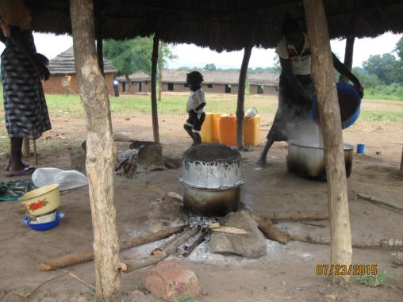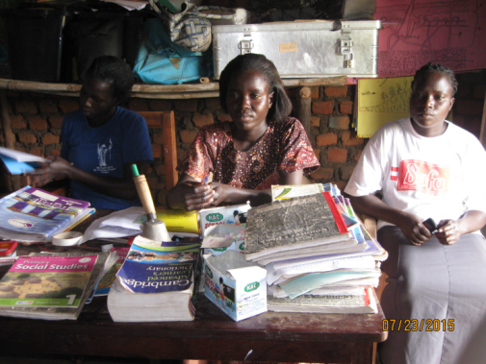

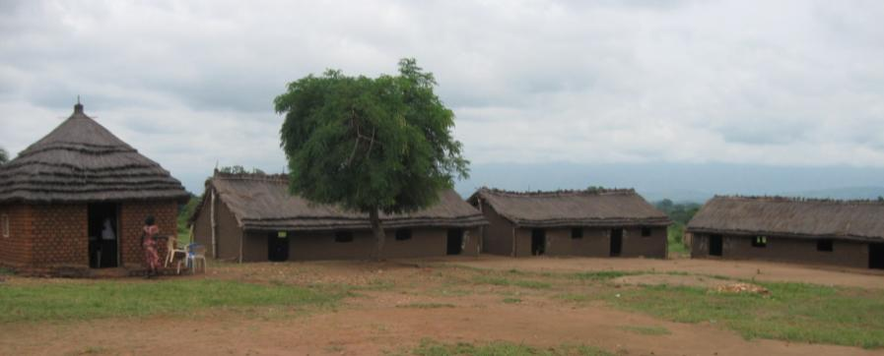

Third meeting was in **Royal Kids international** School. It is newly opened, the school has Nursary, primary and secondary sections.

Meeting was held in a buidling which is under construction. They have no water and food for the children. The population of the school is expected to increase rapidly because of the three section the school have. It is Church oriented foundation but under the management of the community of Pageria payam. The school is headed by a young techer who is explaning his points to the team

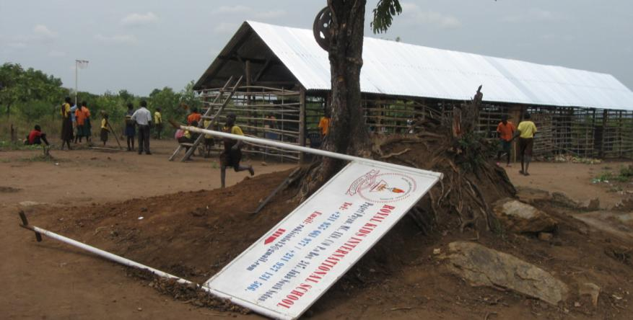

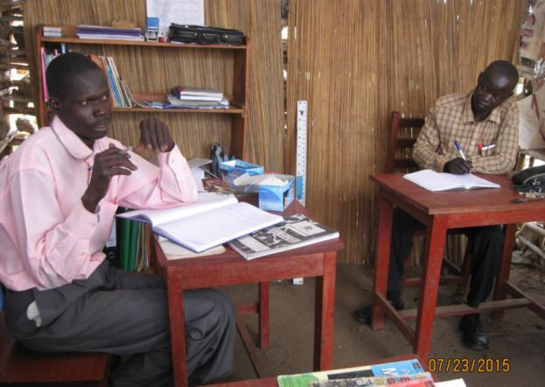

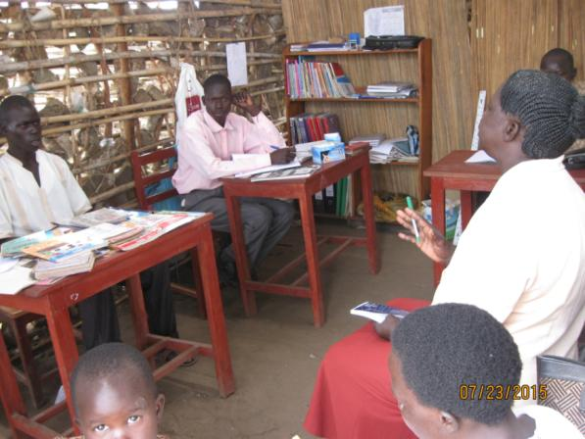

Four school visited was **Orobe primary school**. This school is community initative and since it was opened no any assistant came in for the development of the school. The head mistress of the school is Mrs Gale Muya. It is their first time ever receiving such developmental programm that CAWP and EDOOSS are bringing to the school throught the support of IAS German. The borehole will reduce the risk of accident that the school pupils are ever facing in crossing the road to look for drinking water. Likewise the school garden will provide food and income for devleopment of the school. This was the cry of the community and school authority how to address this issues.

The school is build out of mud soil and grass. The up coming development will be a remarkable event in the history of the school.

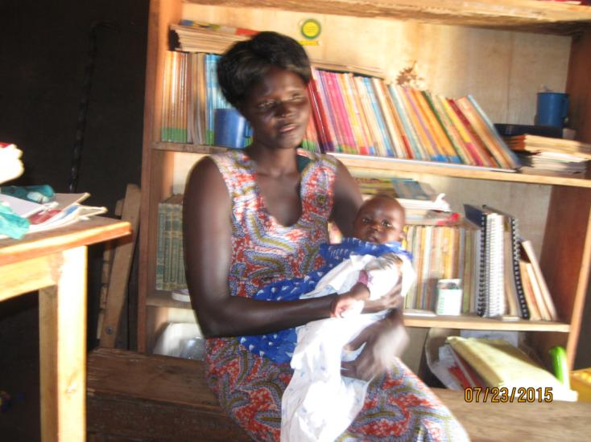

**Progress:**

* Four primary schools were visited
* Four meetings with the school authorities conducted in one day
* All the schools have land ready for school development.
* The project for Water, Sanitation, Hygiene, and Agriculture Programm was official introduced to the Chief Executative Pageria area Administration who is also the chairman of NGOs cluter for Pageria Payam. The fifth meeting was held in his office after the field visit to the four schools.
* Notification of Fund transfered from IAS German to south sudan on process.
* Peace agreement between the opposition and the south Sudanease goverment on high progress.

**Challenges:**

1. Delayment from the bank, fund has not yet reflected into our account.
2. Second season the region is facing insufficent rainfall.
3. Country is experiencing economical crisis, prices in the market keeps on increasing daily
4. Fuel shortage become a big challenge to the entire country, vehicles movement become limited and expensive.